**Thread Management using POSIX Library - Detachment and Cancellation assignments**

Mandatory

1. Write a program to create 3 threads with the detach and cancel status as below.

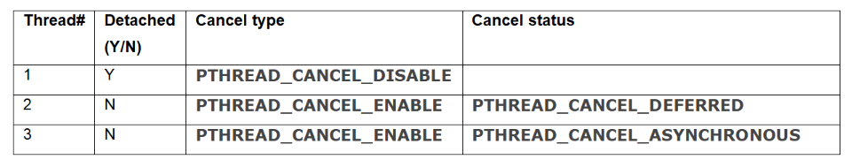

a. Let all the threads read and display their detach, cancel type and status and then display thread specific message as below.

T1: Display message in the format as below every 2 secs

<timestamp> Health OK

T2: Print numbers starting from 1000 in steps of 2 at an interval of 3 secs in format as below.

<timestamp> <threadid> <countvalue>

T3: Print numbers starting from 2000 in steps of 2 at an interval of 3 secs

<timestamp> <threadid> < countvalue >

b. After creating threads, and after 3 minutes from main(), cancel all 3 threads

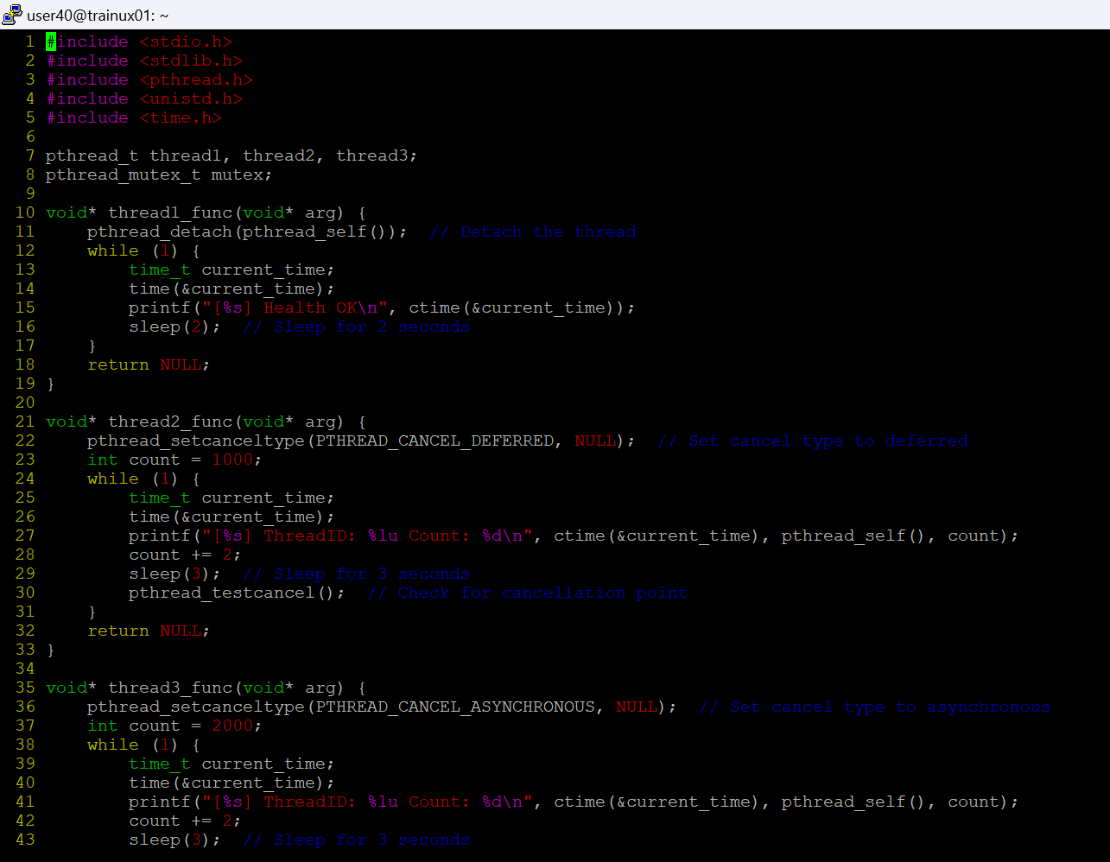

c. From an other terminal, use command below to view the thread count of your program

§ ps -eLF

§ top [For top command usage to refer https://www.golinuxcloud.com/check-threads-per-process-count-processes/ ]

**d. What difference did you observe between top and ps command?**

**ANS:** ps provides detailed thread info with NLWP (number of threads), while top requires toggling to show threads.

**e. Which column shows the number of threads in ps and in top commands?**

Ans: In ps, the NLWP column shows thread count; in top, H is used to toggle and see thread count in the THREADS column.

**f. Check the last message timestamp from the threads**

**Ans:** The last message timestamp is the most recent timestamp printed before threads were canceled.

**g. Which thread was cancelled first and why?**

**Ans:** Thread 1 (detached) was likely canceled first, as it was automatically cleaned up after finishing.

**h. Were all 3 threads cancelled? Justify the observation**

Ans: Yes, all threads were canceled as the main thread called pthread_cancel() after 3 minutes.